**Project Design Phase-II**

**Technology Stack (Architecture & Stack)**

|  |  |
| --- | --- |
| Date | 20 May 2023 |
| Team ID | NM2023TMID02223 |
| Project Name | Industrial Workers Health and Safety System based on Internet of Things |

**Technical Architecture:**

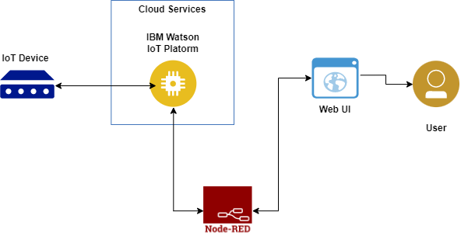

Guidelines:

* Identify key safety metrics
* Conduct a thorough risk assessment
* Select reliable IoT devices and sensors
* Establish a secure network infrastructure
* Set up real-time alerts and notifications
* Ensure worker privacy and consent
* Provide worker training and awareness

**Table-1: Components & Technologies:**

|  |  |  |  |
| --- | --- | --- | --- |
| **S.No** | **Component** | **Description** | **Technology** |
|  | IoT Sensors | These sensors are deployed throughout the workplace to collect data on various parameters such as environmental conditions (temperature, humidity, air quality)etc. | Wi-Fi, Bluetooth, Zigbee etc. |
|  | IBM Watson IoT Platform | The IBM Watson IoT Platform utilizes a combination of technologies to enable the collection, analysis, and management of IoT data. | Cloud Computing, Internet of Things (IoT) Protocols, Device Management |
|  | Node-Red | Node-RED is an open-source flow-based programming tool that provides a visual development environment for connecting IoT devices | Node.js, JavaScript |
|  | Web UI | Web UIs (User Interfaces) rely on a combination of technologies to create interactive and visually appealing user experiences. | HTML, CSS, JavaScript. |
|  | User | When it comes to web UI development, the technology that directly interacts with users typically revolves around enhancing the user experience and providing interactive functionality. | JavaScript, AJAXetc. |

**Table-2: Application Characteristics:**

| **S. No** | **Characteristics** | **Description** | **Technology** |
| --- | --- | --- | --- |
|  | Framework | Node-RED | Node.js, JavaScript |
|  | Security Implementations | Authentication and Access Control | Encryptions |
|  | Scalable Architecture | Cloud Infrastructure | IBM Watson IoT Platform |
|  | Availability | Use of IOT devices | ESP32, DHT sensor etc. |
|  | Performance | Low Latency Communication | MQTT or CoAP |